Low Level Design

Project Code | Group 3
Project Name | Expense Management System

Prepared / Modified by | Role | Date of preparation/ Modification
Group 3 | Analyst | 29-Aug-2018
Reviewed by | Role | Date of review
Approved by | Role | Date of Approval
Circulation List | kavya.lekhana-gurramkonda@capgemini.com  amruta.deokar@capgemini.com  ranjith.vallambhatla@capgemini.com  sejal.jain@capgemini.com  karan.upenja@capgemini.com  manasa.paidi@capgemini.com  rupesh.vishwakarma@capgemini.com  anshu.kumawat@capgemini.com | Version Number : 1.0
Version number of the work product | Version 1.0

Table of Contents

1. Description Of The Unit 3
2. References 4
3. Dependencies / Assumptions 5
4. Class Diagrams 6
5. Sequence Diagrams 7
6. Design Components 8
6.1 List of UI Components…….………………………………………….…………………………………8
6.2 List of Design Classes…………………………………………………………………………………….10

7. Reusable Routines/Components……………………………………………………. 11
8. Messages 12
9. Configuration Files 13
10. Crud Matrix Table 14
11. Data Mapping Matrix 15
12. Action Flow Matrix 16
13. Stored Procedures 17
14. Program Specification / Pseudo Code 18
REVISION HISTORY OF THE WORK PRODUCT 21
Description Of The Unit

This module is aimed to retrieving an expense code details from the database. In this module user is asked to enter an expense code on the basis of which specific expense code details will be displayed. If user enters a wrong expense code or any invalid input then system will show an error message.

Administrator should be able to

- Insert Expense Code Information
- Retrieve Expense Code Information
- Update Expense Code Information
- Delete Expense Code Information
- Retrieve all Expense Code Information

References

Reference | Description
Class Diagram | D:\Expense_Code\PLP Documents\ProjectDocuments\DesignDocuments\HLD\Class Diagram\ExpenseCodeClassDiagram.png
URS | D:\Users\kagurram\Desktop\Expense_Code\Expense_Code\PLP Documents\ProjectDocuments\Requirements\CaseStudy\ExpenseManagementSystemCaseStudy.doc
UTP | D:\Expense_Code\PLP Documents\Testing\UTP\Test_Case_ExpenseCode_getExpenseCode.xls
DB Design | D:\Expense_Code\PLP Documents\ProjectDocuments\DesignDocuments\HLD\DB Design\Expense_Mangement_Group_3DBDesign.xls

Dependencies / Assumptions
Dependencies:
NA

Assumptions:
The expense code details are stored in the MySQL database.

Class Diagrams
Class Diagram

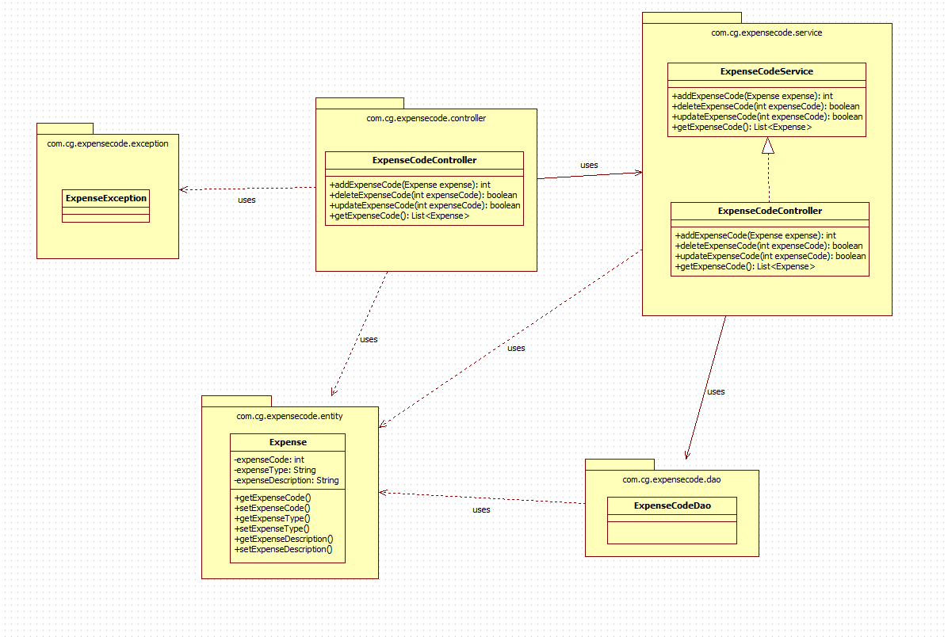

Sequence Diagrams

Sequence Diagram

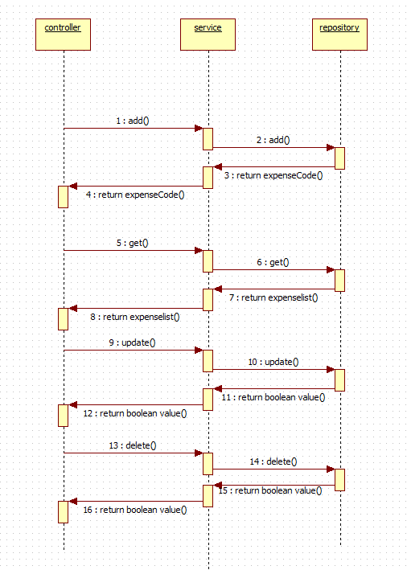

Design Components

List Of UI Components

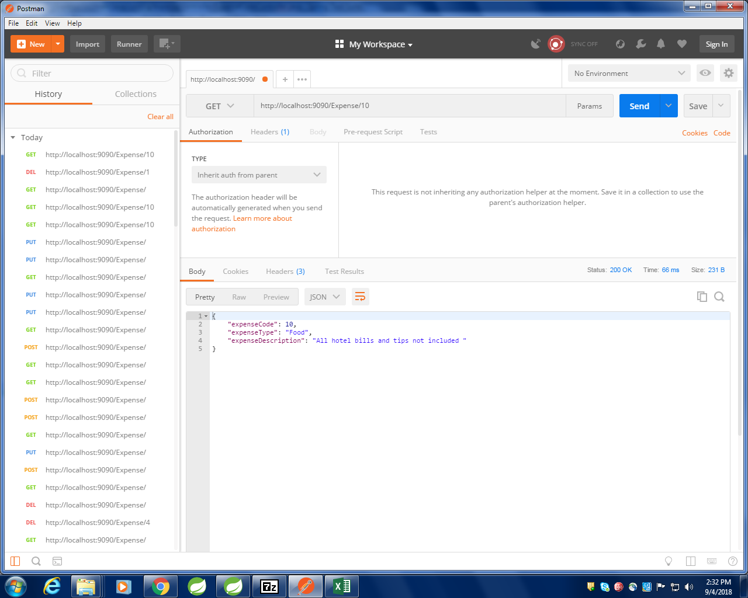

Sr. No. | LLD Name | Class Name | Method Name | Method Description
1 | Expense Code Module | ExpenseCode | Appropriate getters and setters methods | Getters retrieve the property values and setters set the property values
2 | Expense Code Module | ExpenseCodeController | public ExpenseCode getExpense(@Valid @PathVariable Integer expenseCode) | Sets the model attribute.  Calls the Controller method to, retrieve the Expense Code details from the database
3 | Expense Code Module | ExpenseCodeServiceImpl | public ExpenseCode getExpense(Integer expenseCode) | Calls the Service layer method to retrieve the Expense Code details from the database

List Of Design Classes

Re-Usable Routines/Components
Re-Usable Routines/Components

- CustomizedExceptionHandler
- ErrorDetails
- ExpenseNotFoundException
- Logger properties files

Messages

#. | Type | Message Text
M1 | Error | Please fill out this field
M2 | Error | Wrong Expense Code :

Configuration Files

File Name | Path | Description
application.properties | /Development/Source | To configure database connection and port.
pom.xml | /Development/Source | To configure the dependencies

Crud Matrix Table

# | Table Name | Create | Read | Update | Delete
1 | expensecode | N | Y | N | N

Data Mapping Matrix

Sr. No. | Screen Label | Field Source | Field Type | Data Type | Max Length | Data Flow | Mandatory
1 | Expense Code | ExpenseCode. expenseCode |  | int |  | D→UI,  UI→D | Yes
2 | Expense Type | ExpenseCode. expenseType |  | String | 15 | D→UI | Yes
3 | Departure City | ExpenseCode. expenseDescription |  | String | 100 | D→UI | Yes

Legend

UI (User Interface Only)
UI → D (User Interface to Database)
D → UI (Database to User Interface)

Action Flow Matrix

Sr. No. | Action | Description | Process
1 | On Running the code in the console. | Spring Application starts. | The admin clicks on the Run button in the Spring and console generates with the success message. Then open the Postman.
2 | On changing the action panel to GET | The expense code details retrieved from the database. | Data is displayed from the database on enetering the expense code using Postman.

Stored Procedures

# | Stored Procedure Name  (with Description) | Input/Out Parameters | Type | Size
1. | NA

Program Specification / Pseudo Code

<ACTION: INSERT_FLIGHT_INFORMATION >

Pseudo Code:
- Client Side Scripting:
None

- Server Side Scripting:
BEGIN
Call the Service Layer for retrieving the expense code details from the database.
END

Pseudo Code:
14.2 <ACTION: RAISE_REQUISITION >

- Server Side Scripting:
IF Expense Code is Empty
Print Error Message M1
ELSE IF Expense Code is in valid
Print Error Message M2

- Server Side Scripting:
BEGIN
Call public ExpenseCode getExpense(@Valid @PathVariable Integer expenseCode) in ExpenseCodeController
BEGIN
Call public ExpenseCode getExpense(Integer expenseCode) in ExpenseCodeServiceImpl class in Service Layer
BEGIN
Call IExpenseCodeDao interface in Dao layer which in turn interact with JPARepository through which data is retrieved.
END
Return ExpenseCode value to Service Layer
END
Return ExpenseCode value to Presentation Layer
END

REVISION HISTORY OF THE WORK PRODUCT
<To be maintained by projects>

# | Date | Version # | Section Changed | Details of changes made | Approved By
1
2

